Diary No. 4

Week 5: On-Line

Topic: Rules

Date: 23/10/2020

Game Title: Bombs Go KABOOM

Team Members: Muhammed Zulfqar, Sean Colbourne, Tony Hoang and Ali Noorani (myself)

External Play Testing Team Members: James Wilson

1. **The Game Premise:**

The teams had to choose from 2 different type of skills to make their games; Either the **twitch skill** or the **strategic skill**. This team chose the strategic skill based game, to make a bomb defusal game.

They started out by talking about their ideas of how the player was going to defuse the bomb, and how they were going to make this game multiplayer. The game ‘Keep Talking And Nobody Explodes’, where one player uses a VR headset and can see the bomb and a few tasks that player has to do to defuse it, and another player who has a manual on the different tasks, who is telling the player with the VR headset how to complete the tasks in successfully, came into mind and the team decided to use that idea and make it better.

The team decided to introduce some cards into the game from which the player can choose which tasks they will have to complete. The tasks on the cards were going to be invisible to the player, but the player had the freedom to choose which cards they were going to pick, whatever the tasks on the cards. With this the win condition was decided. To win the game, the players must complete all the tasks given to them. Now, for the lose condition, the team decided that there would be a set time limit to the tasks, where the players must complete the tasks within the time limit to win, otherwise the bomb would explode, and they would lose the game.

The team liked the idea, but they wanted to introduce more competition into the game. Hence, they introduced another team into the game, which would also play the exact same game, however this introduced another lose condition into the game, where if one team completed the tasks before the other team and also within the time limit, that team would win instantly and the other teams bomb would explode.

The team also decided that, since there were now 2 teams in competition with each other, the random card selection idea didn’t really make sense as some tasks would take longer to complete than other tasks, and so they decided to remove the cards idea and have the game choose the tasks for the teams. Both teams would now get the exact same tasks.

With these ideas, the team moved onto the design and implementation stage.

1. **The Materials:**

* 2 x VR Headsets (Figure 1)
* 2 x Digital Manuals (Figure 2), accessible through a website.

The digital manual includes the pictures of the different tasks shown in the game in the VR headset.

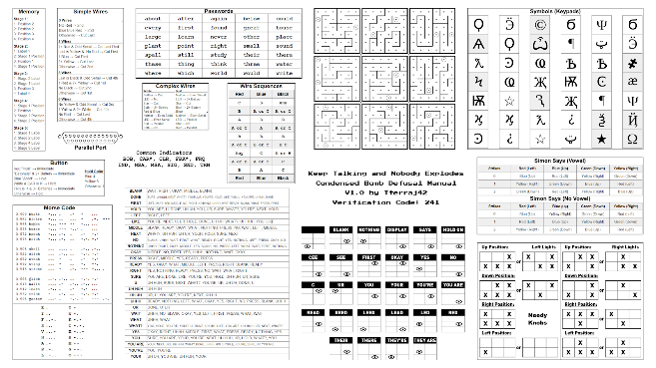

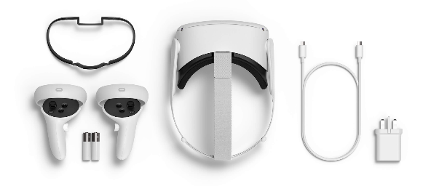

Figure 1: VR Headset Figure 2: Example of Digital Manual

1. **Rules and Mechanics:**

* 2 players per team. 1 player holds the digital manual, the other player has the VR headset.
* To win the game the teams need to complete the 15 required tasks before the other team.
* A time limit of 5 minutes will be given both teams to complete all the tasks.
* Both teams will get the same types of tasks to complete, to keep the game fair.
* If one team completes all 15 tasks within the time limit, before the other team, they win immediately.
* If both teams fail to complete all 15 tasks within the time limit, they both lose.
* The loser’s bomb explodes.

1. **How to Play:**

As this is a VR game and no one in the team had a VR headset, the team was unable to take pictures of the game. The team has however, made a few example tasks seen in Figure 3A, B and C.

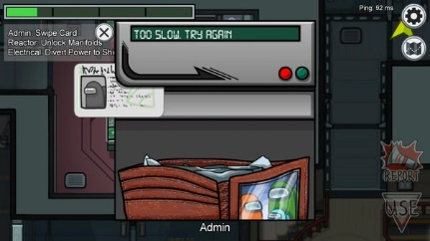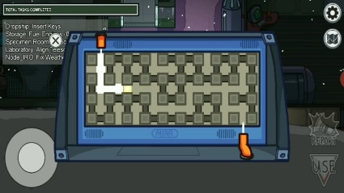

**C**

**B**

**A**

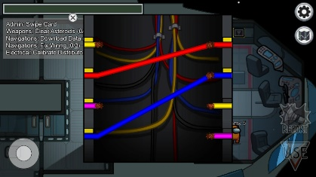

Figure 3: Tasks in Game (A) Wires Task. (B) Card Swiping Task. (C) Weather Node Task

* **Here is a general idea of how to play the game:**
  + The VR player will describe the task in front of them to the player with the manual, in their team.
  + The player with the manual will then describe to the VR player how to complete the task correctly.
  + This carries on until either, one team has completed all 15 tasks, or the time limit of 5 minutes, runs out.

1. **What you found from your play testing and how did the game evolve.**

The team did both internal and external play testing of the game to fix any errors found in the game and to make the player experience much more enjoyable.

In the team’s internal play testing they found that the game was “fun to play with friends” and has “intense competition from the other team”. The team was unable to locate any errors within the game and thought the game had a perfect balance between fun and stress. But, as the team did not have any VR headsets on hand, they had to imagine using one and imagine they could see the tasks in front of them.

As for the external play testing, it was difficult to do as the play tester had to imagine that they were using a VR headset. The game developing team had to tell the play tester what the different type of tasks were for them to call out the correct tasks that were in front of them using imagination. Once the play testing was complete the team was given some reviews.

* “It is really hard to pretend a VR headset.”
* “Really cool game.”
* “I like it.”
* “Requires a VR headset which is expensive”

1. **Your experience of working in teams to solve a problem**

The team solved problems very quickly and effectively by communicating and discussing the problems amongst each other. We had a few problems such as keeping some certain mechanics in the game or not where some wanted to keep it where some wanted to remove it, and those type of problems go solved very quickly by looking at the advantages and disadvantages of the mechanics.

Overall, the team worked well together.

1. **Add a couple of sentences reflecting on what happened in the team. What did you do well in this session and what would you like to improve?**

While working in this team, I found it much easier to communicate through using a calling system rather than typing everything. It was much faster to communicate.

We had some issues of timing where we were running out of the time limit we had set ourselves of 20 minutes to come up with a good idea. We had some ideas in mind and because we did not want to step over the time limit, we decided to stop thinking of new ideas there and finalise the ideas we already had.

We also managed to divide the different tasks into different members and completed everything within the time limit assigned to us.

The one part that went not as great as the planning stage, was the presentation. We ran out of time at the last minute. We were almost finished as we were on the play testing slide. After that slide was the reference slide and then finished. Another problem while we were doing the presentation was that one of the team members microphone had stopped working, so we were sometimes waiting for him to, either introduce himself or speak for his slide. In the end, his microphone did not work and the time used to wait for him to speak, was wasted while it could have been used to talk about the game.